CS4163 - Advanced Networking, Virtualization and Cloud Computing
Practical ICA – (Assessment) 01
Task 02 - IP Addressing and VLAN Segmentation

01.Network Topology Overview
The network consists of a hierarchical design with:
- Core Layer: Two routers (R1 and R2)
- Aggregation/Distribution Layer: Three switches (S5, S6, S7)
- Access Layer: Four switches (S1-S4) connecting eight end devices (PC1-PC8)
Logical separation is implemented using VLANs for Management (VLAN 10) and Guest Users (VLAN 20).

02.IP Addressing Scheme
VLAN Segmentation
VLAN | Purpose | Subnet | Gateway | Usable Range
10 | Management | 192.168.10.0/24 | 192.168.10.1 | 192.168.10.1 - 192.168.10.254
10 | Management | 192.168.30.0/24 | 192.168.30.1 | 192.168.30.1 - 192.168.30.254
10 | Management | 192.168.50.0/24 | 192.168.50.1 | 192.168.50.1 - 192.168.50.254
20 | Guest | 192.168.20.0/24 | 192.168.20.1 | 192.168.20.1 - 192.168.20.254
20 | Guest | 192.168.40.0/24 | 192.168.40.1 | 192.168.40.1 - 192.168.40.254
20 | Guest | 192.168.60.0/24 | 192.168.60.1 | 192.168.60.1 - 192.168.60.254

Inter-Router Connection
- Subnet: 192.168.100.0/30
- R1 (Serial0/3/0): 192.168.100.1
- R2 (Serial0/3/0): 192.168.100.2

End Device IP Assignments
Device | VLAN | IP Address | Gateway | Connected Switch
PC1 | 10 | 192.168.10.10 | 192.168.10.1 | S1
PC2 | 20 | 192.168.20.10 | 192.168.20.1 | S1
PC3 | 10 | 192.168.10.11 | 192.168.10.1 | S2
PC4 | 20 | 192.168.20.11 | 192.168.20.1 | S2
PC5 | 10 | 192.168.30.10 | 192.168.30.1 | S3
PC6 | 20 | 192.168.40.10 | 192.168.40.1 | S3
PC7 | 10 | 192.168.50.10 | 192.168.50.1 | S4
PC8 | 20 | 192.168.60.10 | 192.168.60.1 | S4

03.Router Configurations
Router R1
interface GigabitEthernet0/2.10
encapsulation dot1Q 10
ip address 192.168.10.1 255.255.255.0

interface GigabitEthernet0/2.20
encapsulation dot1Q 20
ip address 192.168.20.1 255.255.255.0

interface Serial0/3/0
ip address 192.168.100.1 255.255.255.252

Router R2
interface GigabitEthernet0/1.10
encapsulation dot1Q 10
ip address 192.168.30.1 255.255.255.0

interface GigabitEthernet0/1.20
encapsulation dot1Q 20
ip address 192.168.40.1 255.255.255.0

interface GigabitEthernet0/2.10
encapsulation dot1Q 10
ip address 192.168.50.1 255.255.255.0

interface GigabitEthernet0/2.20
encapsulation dot1Q 20
ip address 192.168.60.1 255.255.255.0

interface Serial0/3/0
ip address 192.168.100.2 255.255.255.252

Switch Configurations (Example: Switch S1)
vlan 10
name Management
vlan 20
name Guest

interface FastEthernet0/1
switchport mode access
switchport access vlan 10

interface FastEthernet0/2
switchport mode access
switchport access vlan 20

interface FastEthernet0/24
switchport mode trunk
switchport trunk allowed vlan 10,20

04.Testing & Verification

Routing Check:
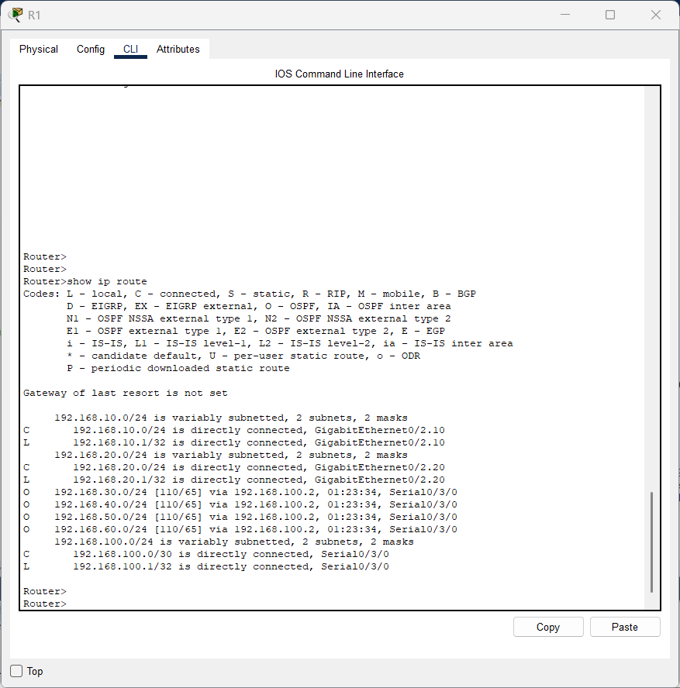

VLAN Verification:
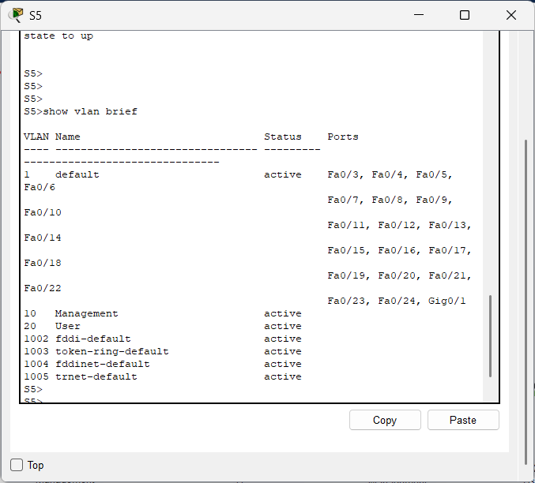

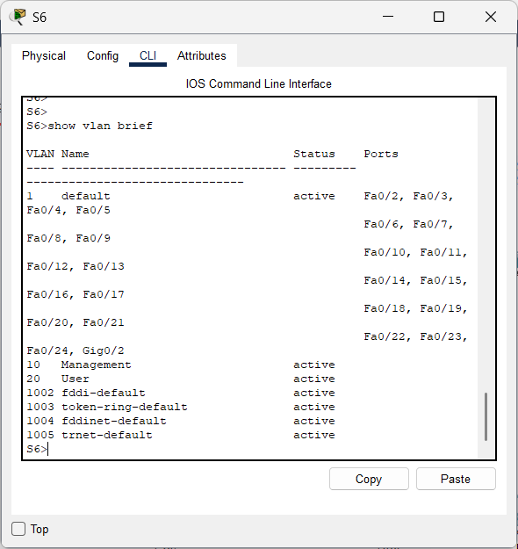

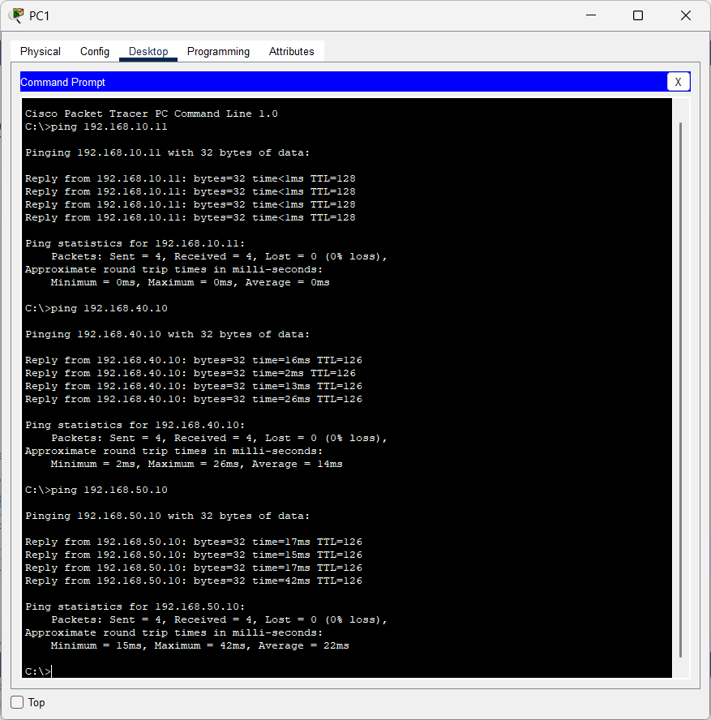
Ping Tests:

